Code & Name of the Course | 1413002043 Blockchain Systems
Lecturer | Prof. Dr. Vedat COSKUN
Name & Lastname | Aşkım Serra ŞAHİN
Student ID | 230502002
URL of Your Project | https://github.com/askimserra/FreshChainV2
Admin Account | 0x88bB99628186dBD0d15177C913F938087961984a
Producer Account | 0xD3B9B0E134F5Ba7d85892d9F8fd138BeEB5B5696
Transporter Account | 0xb677388cA6775f6145A805EE8b8783c28d0aFd0c
Distributer Account | 0x561DaBA7D68973a0095FBc8897f43B4ebDC900bf
Retailer Account | 0xb15300b34bB3EC58A21F796Bbeec2A9ad7EE6A70
FRESHCHAIN DAPP PROJECT REPORT VERSION 2

- PROJECT DESCRIPTION
1. Project Description and Problem Statement
FreshChain is a decentralized traceability solution designed to restore trust in the global food supply chain. Food Traceability refers to the ability to track any food constituent through all stages of production, processing, and distribution. It is critical for ensuring food safety, as it allows for rapid intervention during health crises.
Why Blockchain?
Traditional systems are centralized, making data vulnerable to alteration or loss. FreshChain utilizes blockchain technology to provide:
- Transparency: All stakeholders can view the journey of a product.
- Immutability: Once data is recorded on the ledger, it cannot be deleted or changed.
- Trust: Automated logic replaces the need for mutual trust between unknown parties.
- The Problem: Traditional supply chains rely on centralized databases that are susceptible to data manipulation, lack of transparency, and delayed accountability. When a food product spoils due to improper handling (e.g., temperature spikes), it is often difficult to prove whether the fault lies with the Producer, Transporter, or Distributor.
- The Solution: FreshChain utilizes the Ethereum (EVM) blockchain to create an immutable ledger of every event in a product's lifecycle. By leveraging Smart Contracts, the system implements an Automated Penalty Logic: if a transporter fails to maintain safety thresholds (e.g., temperature > 25C), their deposited collateral is automatically forfeited to the producer as compensation, removing the need for third-party arbitration.

2. Conceptual System Architecture
The system is built on a hybrid architecture that balances the security of Web3 with the accessibility of Web2.
- Smart Contract Layer (Solidity): Acts as the "Single Source of Truth." It handles role management, ownership logic, escrow deposits, and real-time sensor data validation.
- Frontend Layer (React & Ethers.js): Provides an intuitive interface for actors to interact with the blockchain without needing to write code.
- Web3 Interaction (Write Access): Authorized actors (Producers, Transporters, etc.) use MetaMask to sign transactions. This ensures that every data entry is cryptographically signed and non-repudiable.
- Web2 Public Interface (Read-Only Access): Consumers can access the product's history via a QR code. This interface performs read-only queries to the blockchain, allowing public transparency without requiring a wallet or technical knowledge.

3. Actors, Roles, and Permission Matrix
The system implements Role-Based Access Control (RBAC) using Solidity modifiers. This ensures that only authorized entities can modify the state of a batch.
Actor | Technical Modifier | Permission Type | Responsibility
Admin | onlyAdmin | Full Access | Registering/authorizing actors and triggering the Emergency Stop (paused).
Producer | onlyProducer | Write/Read | Initializing a "Batch" and setting the expiryDate.
Transporter | onlyTransporter | Write/Read | Claiming ownership by depositing 0.0001 ETH (Escrow) and logging real-time sensor data.
Distributor | onlyActor | Write/Read | Managing intermediate logistics and verifying batch integrity.
Retailer | onlyRetailer | Write/Read | Conducting final quality inspection and finalizing the batch (finalize).
Customer | Public | Read-Only | Scanning QR codes to view the "Audit Trail" and safety status.

Strategic Distinction: "Write" permissions are restricted to verified stakeholders to maintain data integrity, while "Read" access is open to the public to foster consumer trust.
4. Use Case Descriptions
The system represents each product as a "Digital Twin" on the blockchain.
- U.C. 1: Batch Creation: The Producer registers a new batch with a unique ID, quantity, and shelf-life.
- U.C. 2: Escrow-Backed Ownership Claim: A Transporter must send ETH to the contract to "Claim" a batch. This collateral is locked in the contract to ensure the transporter has "skin in the game."
- U.C. 3: Transparent Environmental Logging: While in transit, the Transporter logs temperature and humidity. The contract instantly validates these against safety thresholds.
- U.C. 4: Finalization & Refund: Upon arrival, the Retailer approves the shipment. If no violations occurred, the contract automatically refunds the collateral to the transporter.

5. Sequence Diagrams
A. Batch Lifecycle & Financial Flow
This diagram illustrates the chronological movement of a batch and the associated financial escrow mechanism:
- Producer: Executes createBatch().
- Transporter: Executes transferOwnership() + Deposits ETH (Collateral).
- Transporter: Executes addSensorData() per-interval.
- Retailer: Calls markAsArrived(), which triggers the final state change and either refunds or penalizes the transporter.
B. Customer Verification Flow (QR Code)
This diagram explains how a consumer verifies the product's journey:
- Customer scans QR Code -> Frontend extracts the Batch ID from the URL.
- Frontend Query -> Calls the getBatchHistory(id) view function.
- Blockchain Response -> Returns the full timestamped sensor history and ownership chain for display.

6. Data Model and Logical Structure
The system data is structured logically rather than just as a collection of variables:
- Batch Struct (State Machine): Each batch is a self-contained object representing the product's current state. It tracks the currentOwner, isFinalized status, and the isViolated flag which is automatically determined by the contract's logic.
- SensorLog Struct (Event Logging): Instead of overwriting data, the system uses an array of structs to store every sensor reading. This creates a time-series history that cannot be altered.
- Ownership Array: An address[] array captures the "Digital Fingerprint" of every handler. This establishes an unbreakable chain of custody.
- Automated Escrow & Inspection Logic: The inspection status (passedInspection) and the violation flag (isViolated) are logically linked to the collateral variable. This ensures that the financial outcome (refund or penalty) is a direct consequence of the logged data and perakendeci's final verification.

- PROJECT USAGE
1. System Access and Role Detection
FreshChain V2 is a decentralized application (DApp) that uses MetaMask for identity rather than traditional passwords.
- Wallet Connection: Upon visiting the site, click "Connect Wallet." The system automatically reads your public Ethereum address.
- Role Identification: The interface is dynamic. Using the smart contract's internal mappings, the system checks if your address is a Producer, Transporter, Distributor, or Retailer and updates the sidebar accordingly.
- Instructor/Admin Access: To ensure a seamless evaluation, the Admin account is predefined. On the login/admin screen, the credentials are fixed and auto-filled. The instructor simply needs to click the "Connect Admin" or "Authorize" buttons without manual entry.

1.1 FreshChain DApp Page
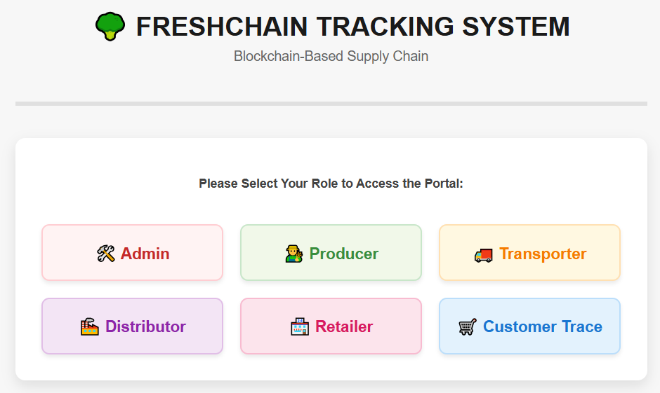

1.2 Role-Based User Interfaces
1.2.1 Admin
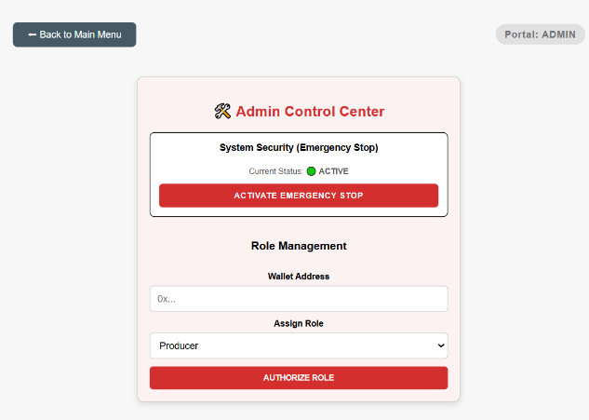

1.2.2 Distributor
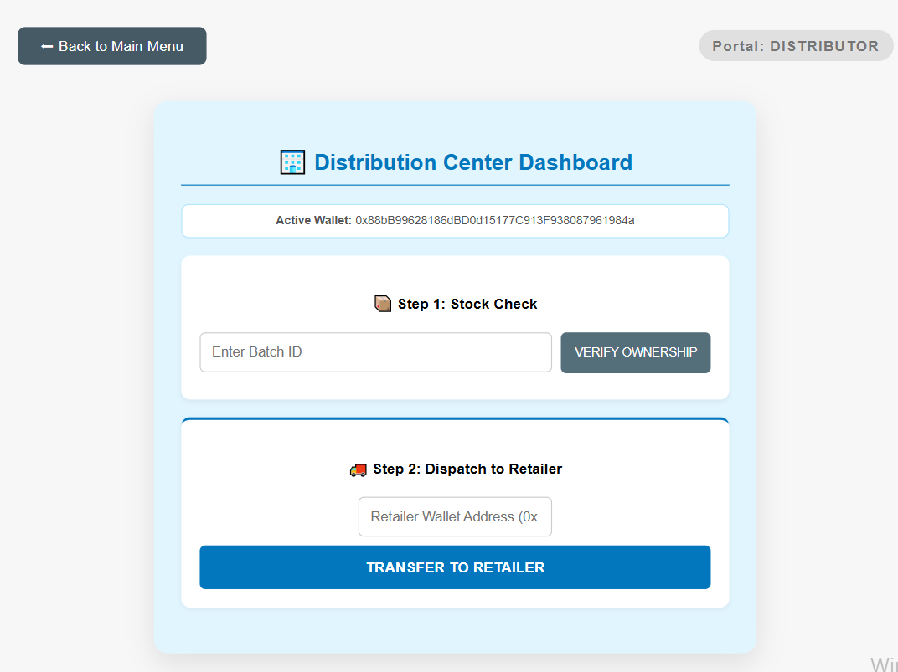

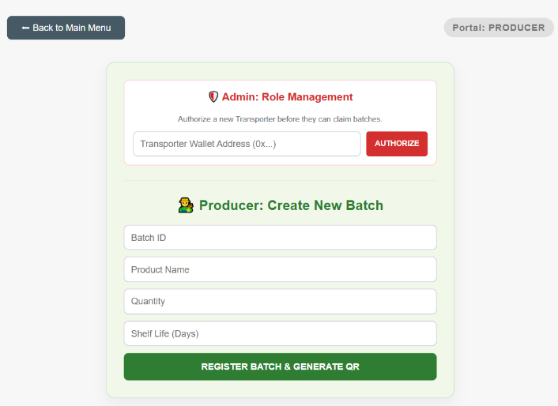
1.2.3 Producer

1.2.4 Transporter
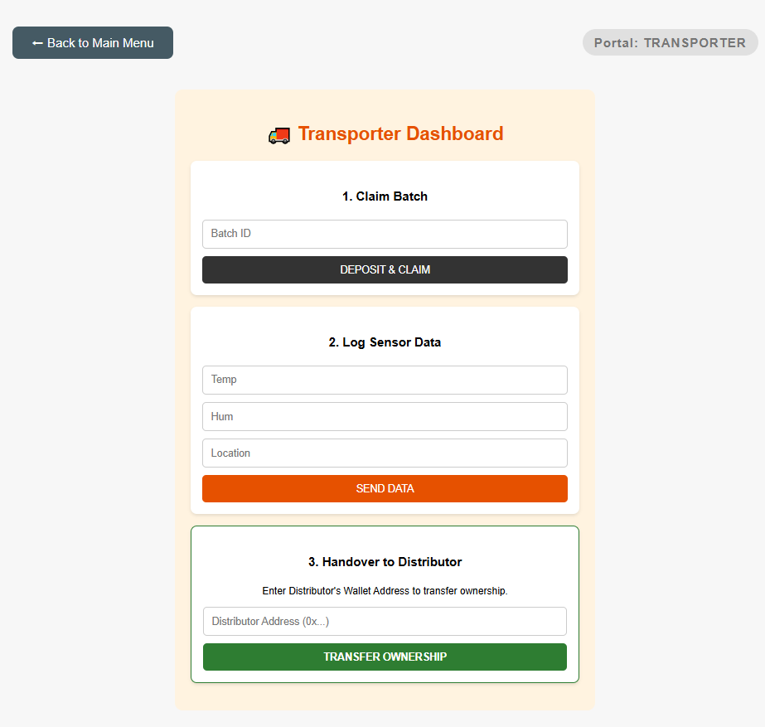

1.2.5 Retailer
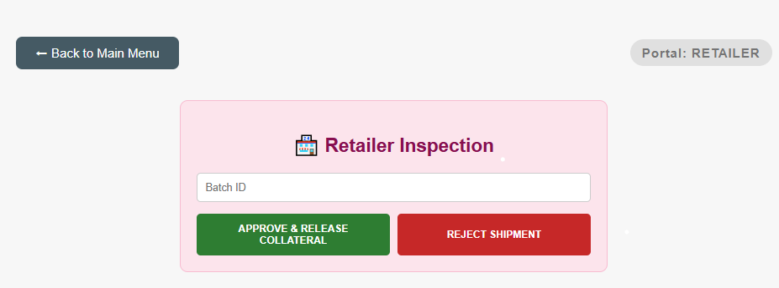

1.2.6 Customer
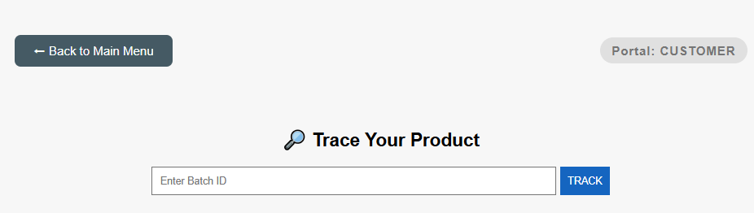

2. Admin Operations: Building the Network
The Admin must register participants before they can interact with the blockchain.
- Registration: The Admin enters a participant's wallet address and selects their role.
- Blockchain Effect: Clicking "AUTHORIZE ROLE" updates the producers, transporters, etc., mappings on the smart contract.
- Emergency Stop: The Admin has a unique "ACTIVATE EMERGENCY STOP" button. If activated, the whenNotPaused modifier prevents any further transactions, securing the system during critical events.

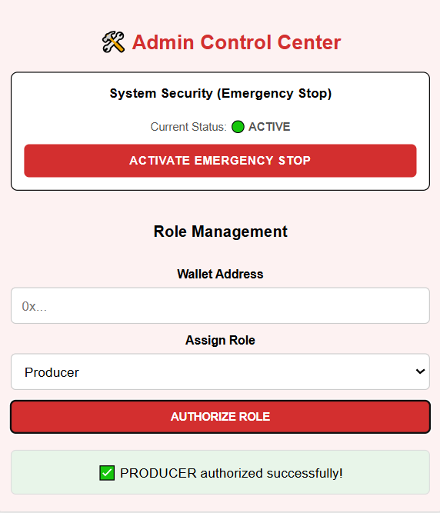
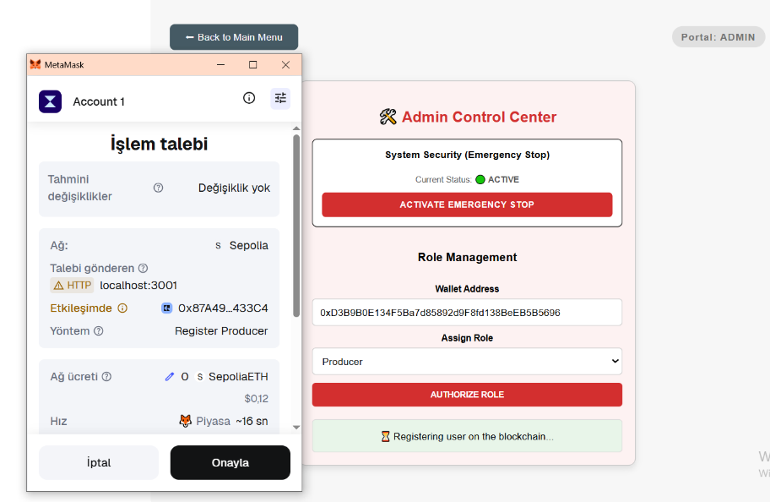
2.1 Producer Authorization

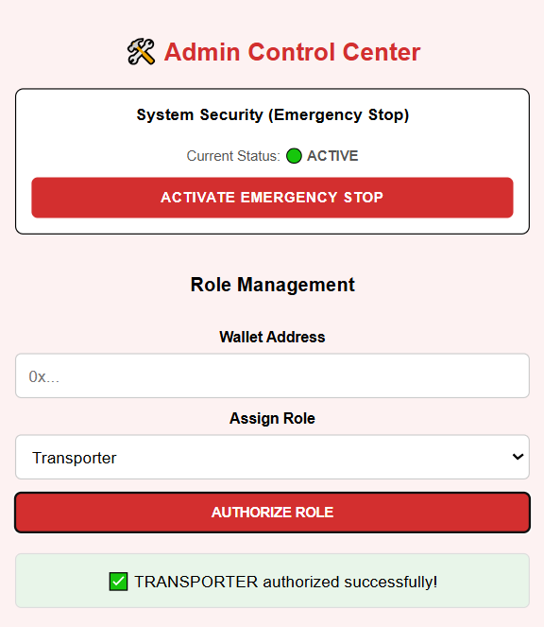
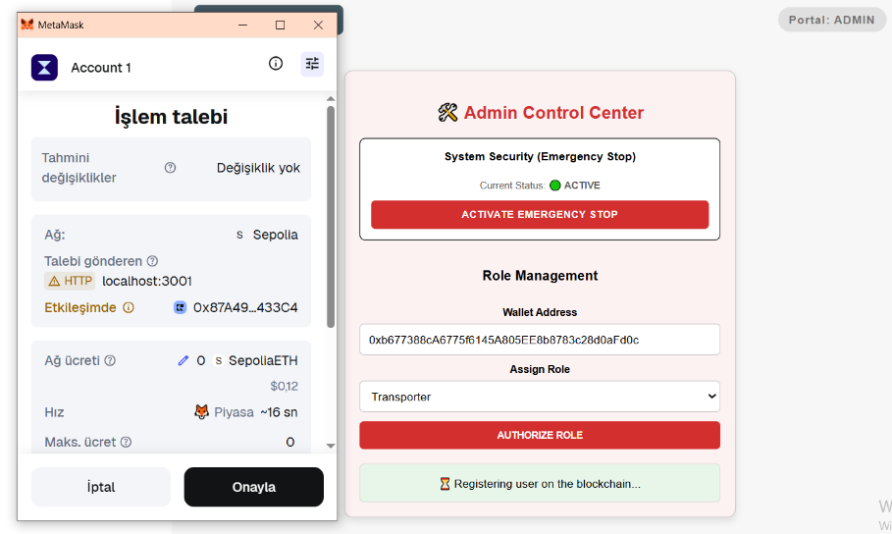
2.2 Transporter Authorization

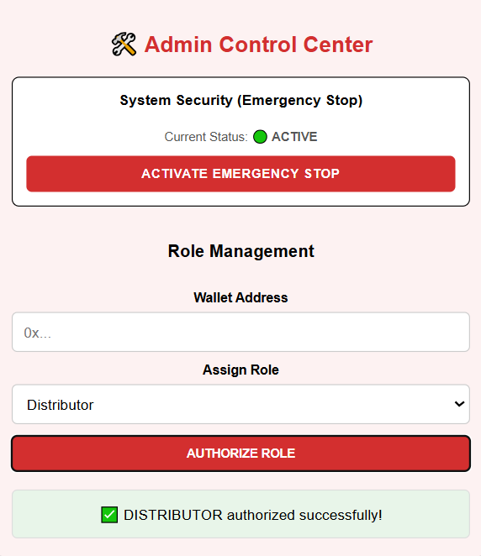
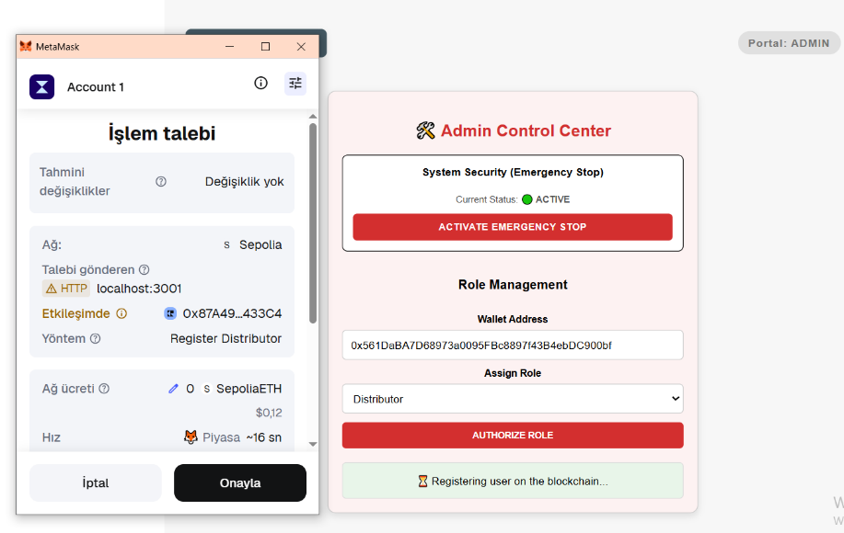
2.3 Distributor Authorization

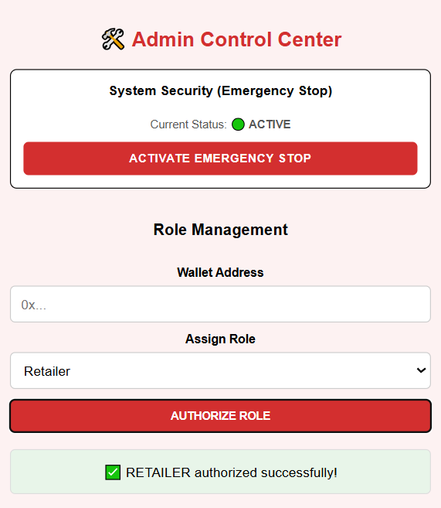
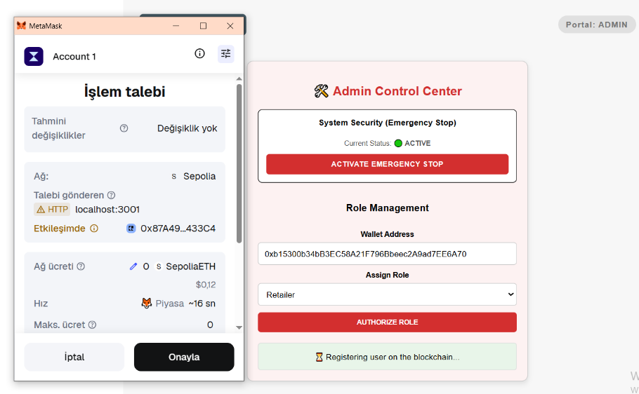
2.4 Retailer Authorization

3. Producer: Creating Batch #200
Once authorized, the Producer initiates the product's journey.
- Creating a Batch: Using your specific data, the Producer enters:
  - Batch ID: 200, Product Name: Apple, Quantity: 350, Shelf Life: 20 (Days)
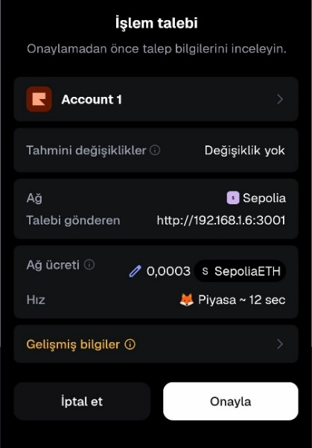
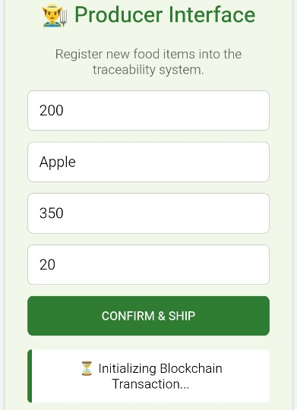
- On the Blockchain: When "REGISTER BATCH" is pressed, the contract creates a new Batch struct. This hardcodes the producer’s address as the origin and sets the expiryDate by adding 20 days to the current block timestamp.

4. Visibility and QR Generation
- List Batches: Users can view all active goods using the LIST BATCHES function. This dashboard includes mandatory predefined batches (like Batch #1: Organic Milk) to ensure the system is never empty during a demo.
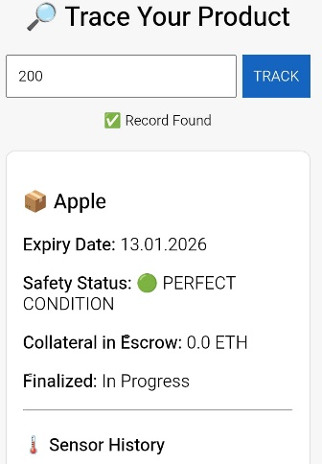
- QR Code Visibility: The moment Batch #200 is registered, a unique QR Code is generated using the QRCodeSVG component. This QR becomes visible on the Producer's dashboard and is physically attached (conceptually) to the apple crates.
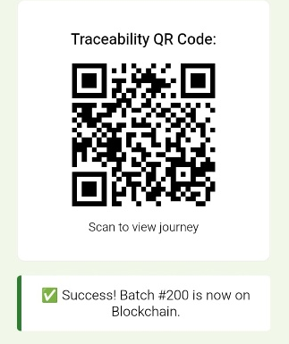

5. Transfer to Transporter
- The Admin digitally transfers Batch ID 200, which they produced, to the authorized Transporter wallet address for physical shipment. This transaction records on the blockchain that the title and responsibility for the product now belong to the Transporter.
The Transporter now becomes the legal owner of the product and is responsible for executing the next step in the chain.
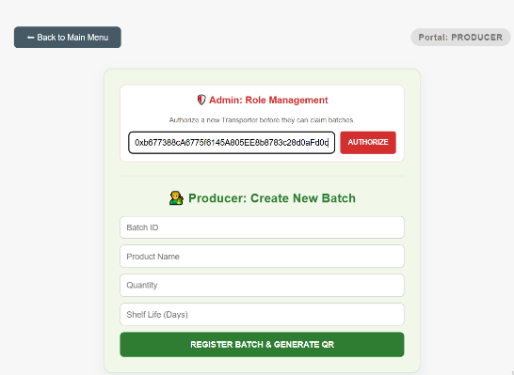

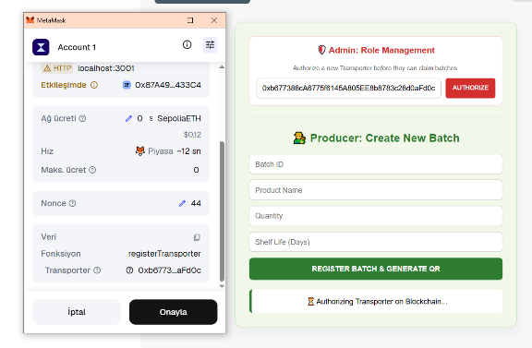

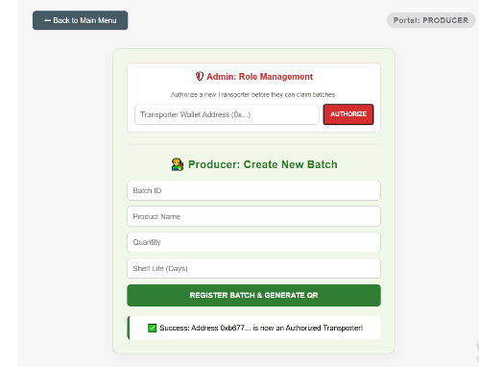

6. Logistics: Ownership & Sensor Data
Ownership is transferred to move the product through the chain.
- The Pull (Claim): A Transporter selects Batch #200 and clicks "CLAIM BATCH."
- Collateral: Per the code, the Transporter must send 0.0001 ETH as collateral. This "escrow" ensures the transporter is financially responsible for the apples.
Environmental Recording
While the apples are in transit, the Transporter logs live data:
- Inputs: Temperature: 20°C, Humidity: 26%, Location: Denizli.
- Validation: The system checks these values against safety thresholds. Since 20°C is within the safe range (below 25°C), the batch remains marked as "PERFECT CONDITION."
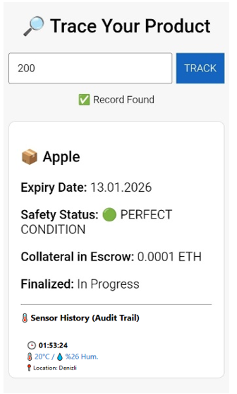
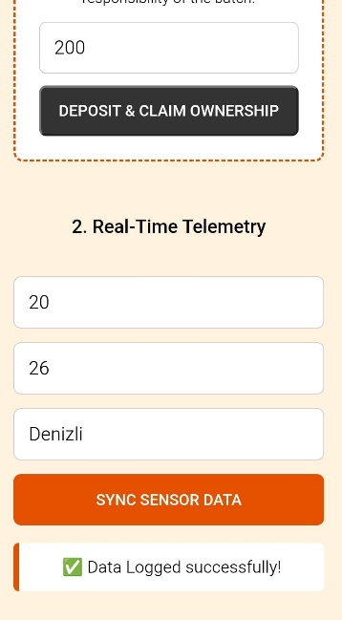
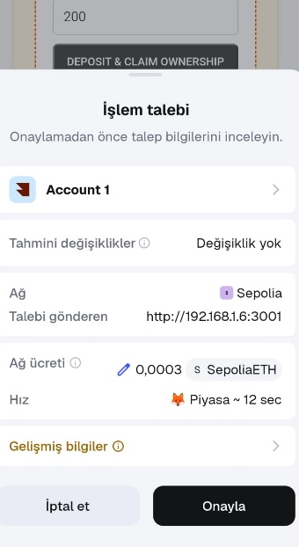
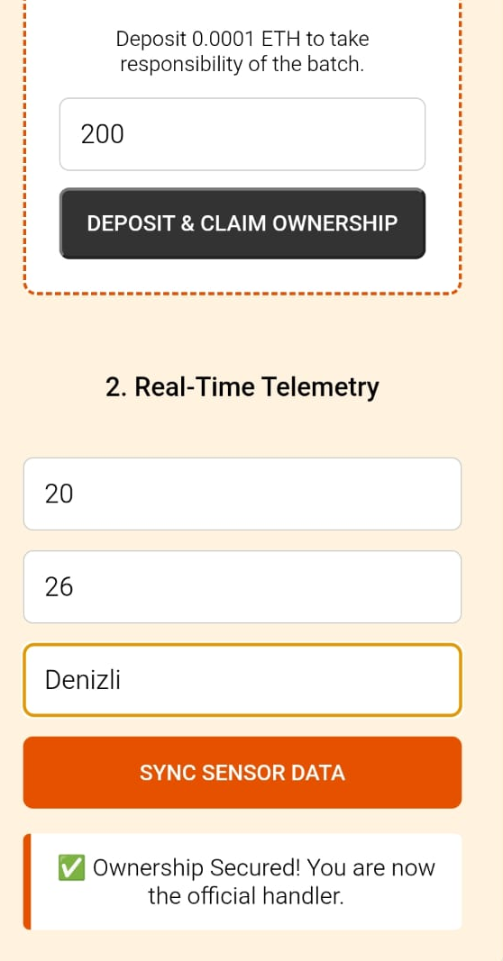

7. Transfer to Distributor
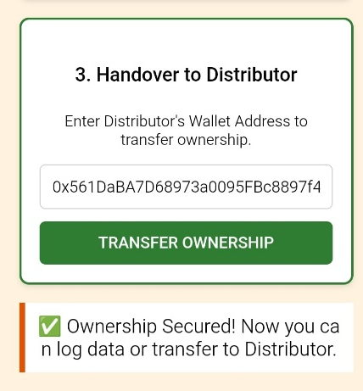
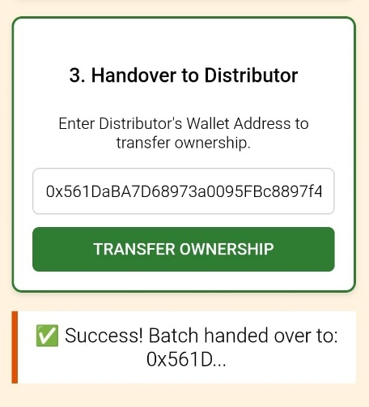
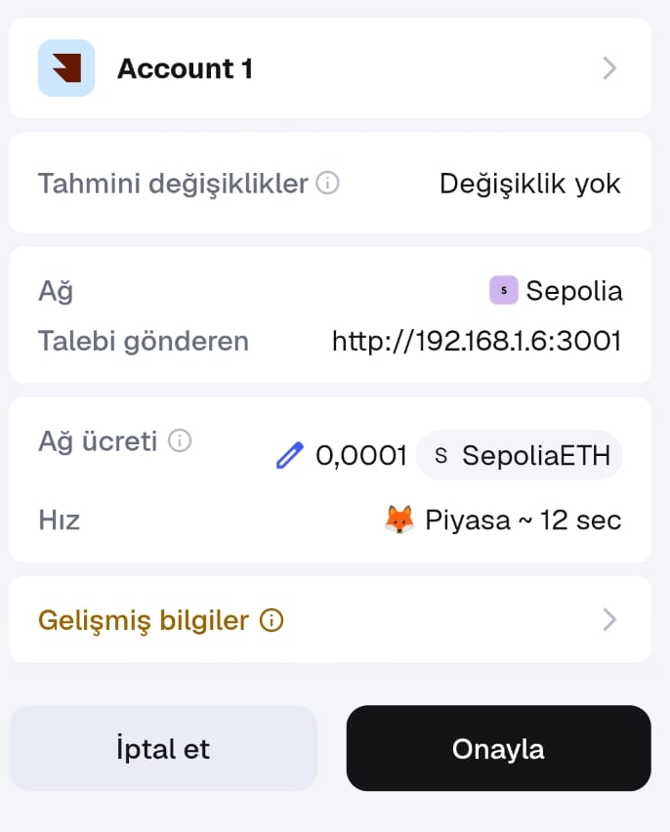
- Once the Transporter reaches the warehouse, they enter the Distributor's wallet address.They click the "TRANSFER OWNERSHIP" button. The apples are now legally and digitally moved to the Distributor's inventory.

8. Distributor: Verification and Dispatch
The Distributor ensures the inventory is correct before moving it to the store.
- Step 1: Verify Ownership: The Distributor enters Batch ID 200 and clicks "VERIFY OWNERSHIP." The system checks the blockchain and displays a success message:
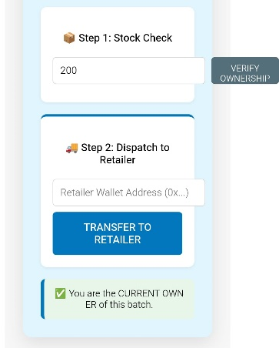
" You are the CURRENT OWNER of this batch."

- Step 2: Transfer to Retailer: Once ownership is confirmed, the Distributor enters the Retailer's wallet address and clicks the "TRANSFER TO RETAILER" button. The digital ownership of the apples is now officially moved to the store.
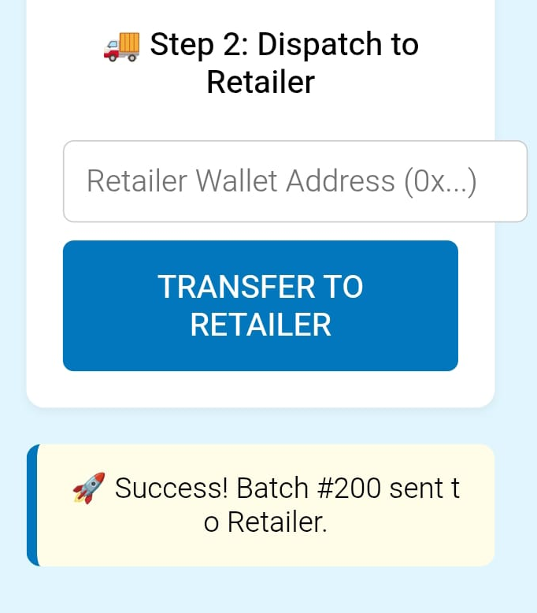
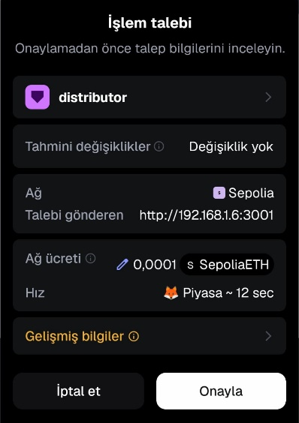
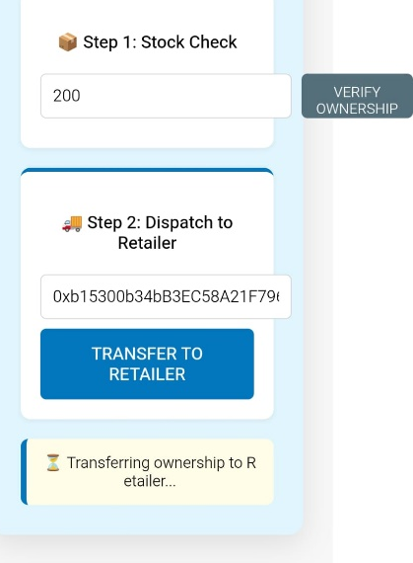

9. Retailer: Final Inspection
When the shipment reaches the store:
- Arrival Check: The Retailer (the current owner) reviews the sensor history.
- Finalization: The Retailer clicks "APPROVE SHIPMENT." * The Result: The markAsArrived function is called. Because isViolated is false, the smart contract automatically refunds the 0.0001 ETH collateral to the Transporter. The batch status is set to isFinalized, locking the history forever.
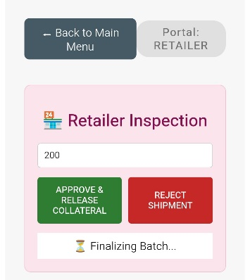
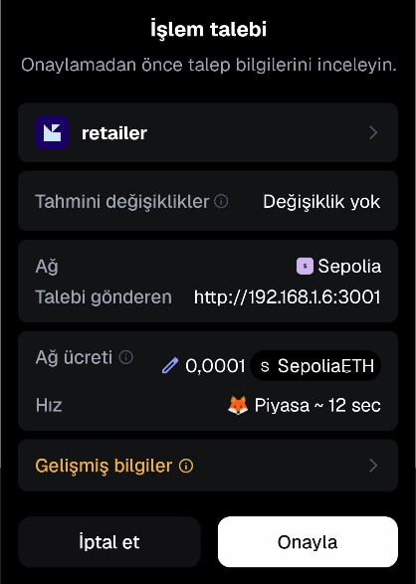
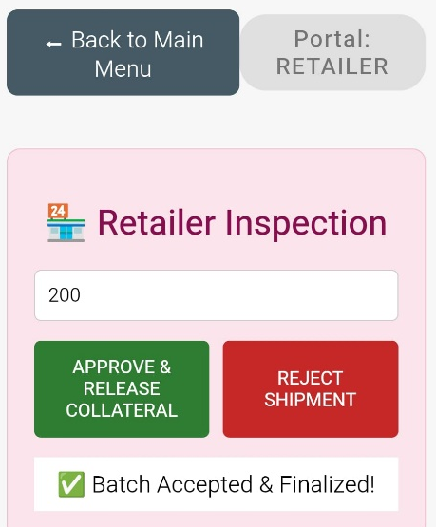

10. Customer: Public Traceability
The most critical part of FreshChain is providing the end-consumer with absolute proof of quality.
- Manual Search: A customer enters TrackID: 200 on the customer portal and clicks "GET HISTORY."
- Visual Audit Trail: They see the full history: produced in the orchard, transported through Denizli, and the exact temperature logs (20°C).
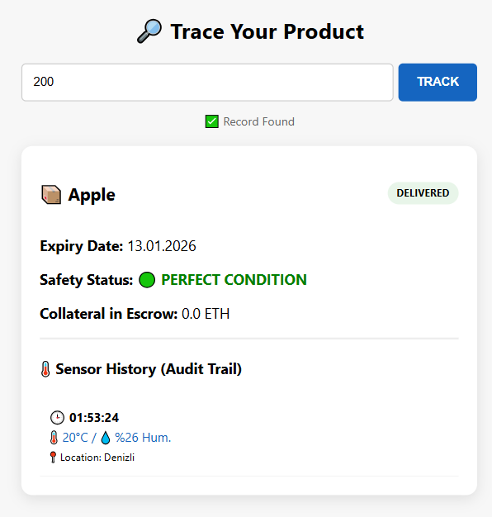

- The Mobile QR Experience:
  - The portal displays a large QR code for the specific batch.
  - A customer scans this with their phone camera.
  - The phone opens the history page directly in Mobile Chrome.
  - Crucial Benefit: This page is "Read-Only." The customer does not need to log in, does not need MetaMask, and does not need ETH. They see the same immutable blockchain data as the professionals, ensuring 100% trust.

11.Features for Different Scenarios
11.1 Emergency Stop (Circuit Breaker) Feature
The Emergency Stop feature follows a cross-layer synchronization pattern to ensure total system lockdown when needed.
1. Smart Contract Layer (The Single Source of Truth)
The contract maintains a global boolean state, typically named paused.
- Role: Acts as the master switch.
- Logic: Functions intended to be restricted during an emergency are wrapped with a whenNotPaused modifier (in Solidity) or check the paused variable before execution.
2. Admin Dashboard (The Control Trigger)
The Admin.js component acts as the remote control for the contract's security state.
- Transaction: When the Admin clicks the toggle, it initiates a state-changing transaction on the blockchain.
- Signer: This requires a wallet signature from the Contract Owner, ensuring only authorized personnel can lock/unlock the supply chain.
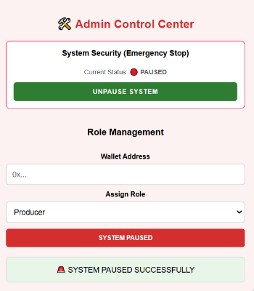
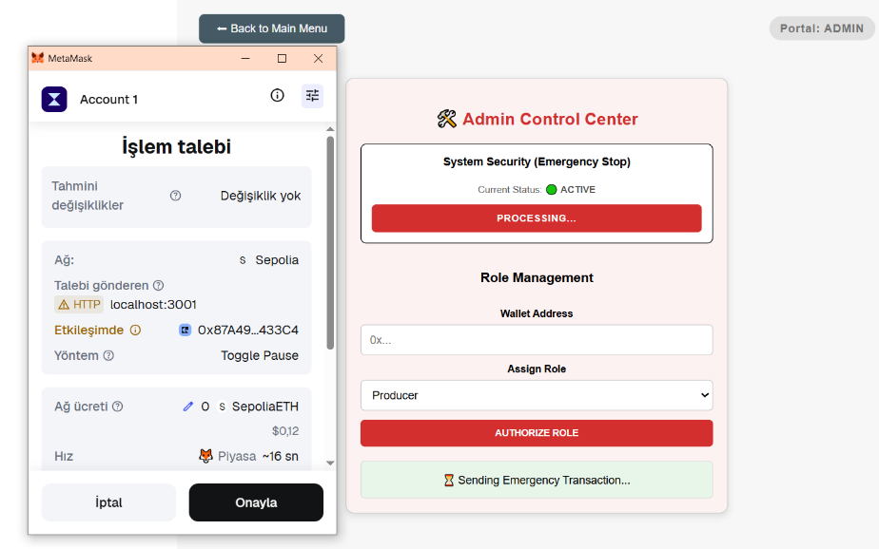

3. Customer Portal (The Defensive UI)
The Customer.js component acts as a proactive gatekeeper to prevent unnecessary network calls and improve User Experience (UX).
- Active Polling: Using useEffect, the app checks the paused() state every 30 seconds to catch an Admin's toggle in real-time.
- Pre-Flight Check: Before the fetchHistory function runs, it performs a final check:
If (paused == true) ->Abort Search.
- UI Feedback: It dynamically disables input fields and buttons, replacing them with a "System Locked" notification to inform the user why services are unavailable.
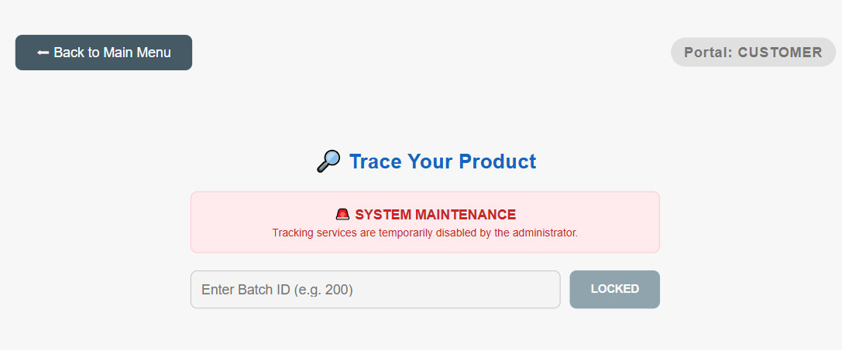

11.2 Quality Violation Feature: Thermal Breach & Automated Penalty
To test the system’s integrity, we simulated a critical failure during the logistics phase for a high-sensitivity perishable item.
The Scenario: A cooling system failure occurs in the transport vehicle arriving at the Kocaeli hub, causing the internal temperature to rise to 27°C.
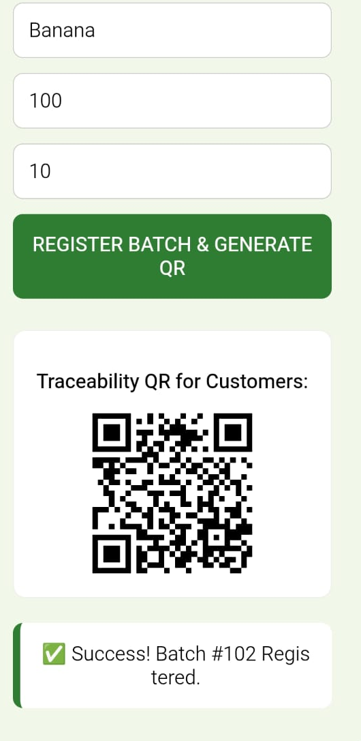
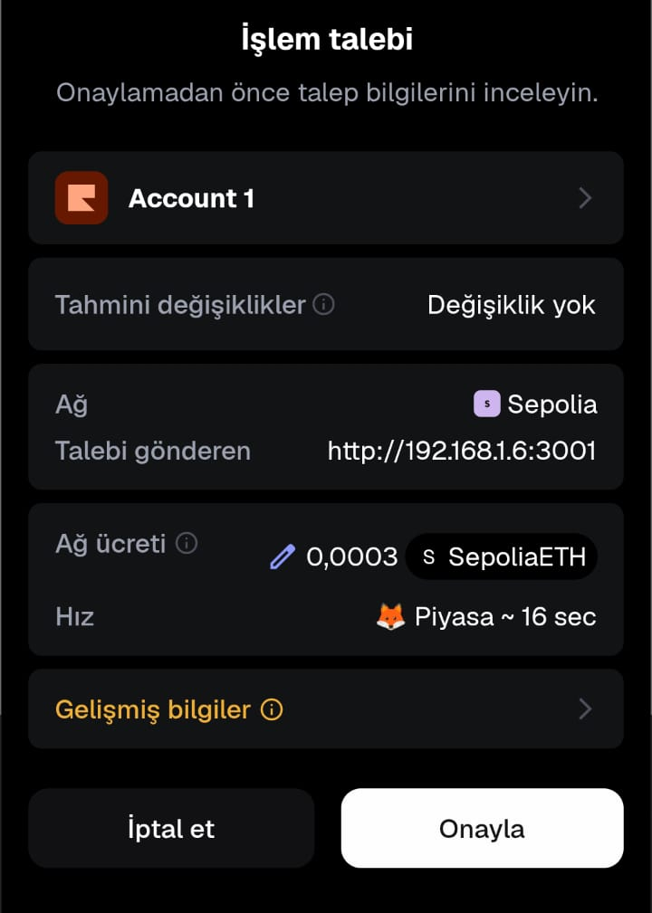
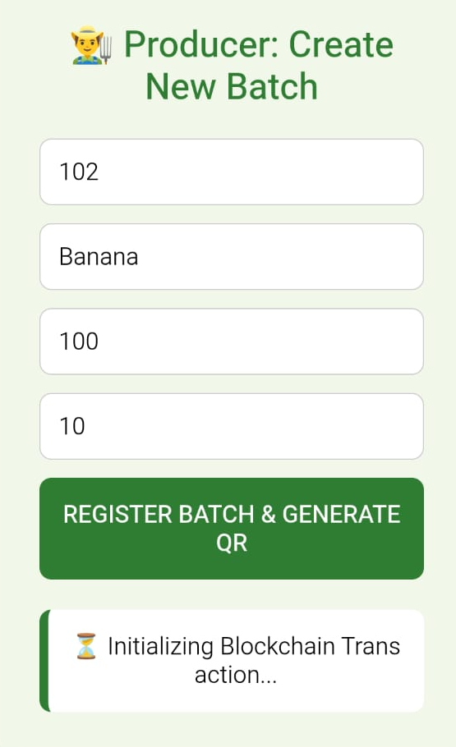

1. The Violation Flow
- Data Submission: The Transporter logs the current location as "Kocaeli" and is forced to record the actual sensor data: 27°C and 20% Humidity.
- Automated Penalty: The smart contract’s internal logic (if temperature > 25) is instantly triggered upon submission.
- State Update: The system automatically updates Batch #102 (Bananas) with the status isViolated = true.
- Instant Compensation: The 0.0001 ETH collateral previously deposited by the Transporter is immediately seized by the smart contract and transferred to the Producer’s wallet as a penalty for the quality breach.
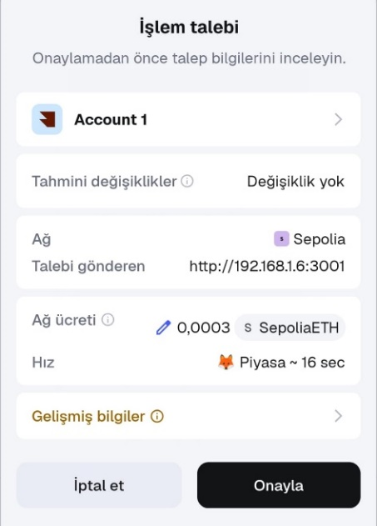
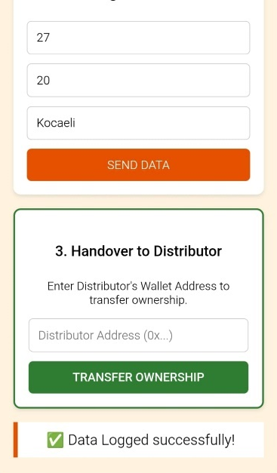
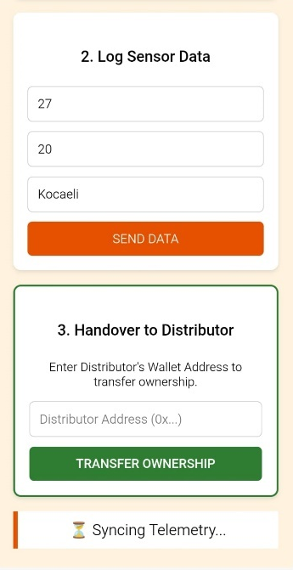

2. Interface Impact (UX)
- Customer View: Any user tracking the product no longer sees the green "Perfect Condition" status. Instead, a bright warning appears: " VIOLATION DETECTED: High Temperature Breach".
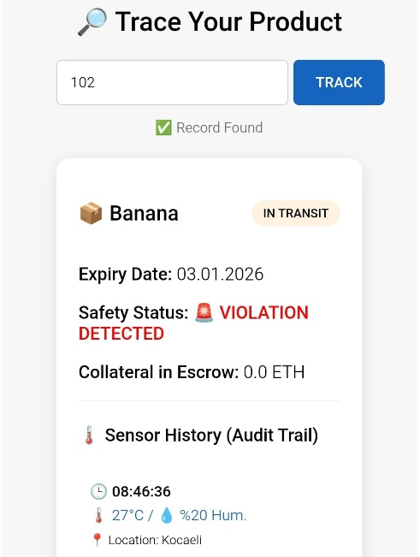

- Retailer View: When the Retailer receives the shipment in the UI, they are alerted to this specific breach in Kocaeli, allowing them to Reject the Shipment before offloading.
- Refund Cancellation: Even if the product reaches its destination, the system refuses to release the collateral back to the Transporter because the isViolated flag is permanent.

3. What Happened on the Blockchain?
- Boolean State Change: The isViolated variable for Batch #102 shifted from false to true. This data is now permanently etched into the blockchain, marking these 100 bananas as "Quality Compromised."
- Automated Escrow Transfer: The 0.0001 ETH collateral is no longer held in the contract. The contract autonomously routed these funds to the Producer, acting as a decentralized judge and executioner based on the sensor evidence.
- Loss of Claim Rights: In a successful delivery, the Transporter would receive their deposit back. Because of the violation in Kocaeli, the contract's internal balance for this batch is now 0, meaning no refund can ever be processed.

4. Validation Test Report (Batch #102)
Field | Details
Product / Quantity | Banana / 100 Units
Location | Kocaeli Warehouse
Test Input | 27°C Temperature / 20% Humidity
Expected Result | Contract triggers violation, flags batch #102, and transfers collateral to Producer.
Actual Result | UI displayed " VIOLATION DETECTED". Blockchain explorer confirmed isViolated: true and collateral: 0.
Status | PASSED (Penalty Successfully Enforced)

C.PROJECT TECHNICAL DETAILS
1. Component Architecture
The FreshChainV2 system is built on a decentralized three-tier architecture. It connects a React-based frontend to an Ethereum-compatible blockchain via a middleware provider.
- Frontend Layer (React & Ethers.js): The user interface is built with React. Ethers.js acts as the bridge, communicating with the blockchain. It uses BrowserProvider to interact with MetaMask for signing transactions.
- Integration Layer (MetaMask/Provider): This layer handles the security and connectivity. It manages the user’s private keys and broadcasts signed transactions to the network.
- Blockchain Layer (Solidity Smart Contract): The core business logic resides here. All roles, batch data, and sensor logs are stored in a state-managed Solidity contract on the EVM (Ethereum Virtual Machine).
- Public History Pages: These are specific frontend routes (like the Customer Portal) that allow non-authorized users to read data from the blockchain without needing to sign transactions.
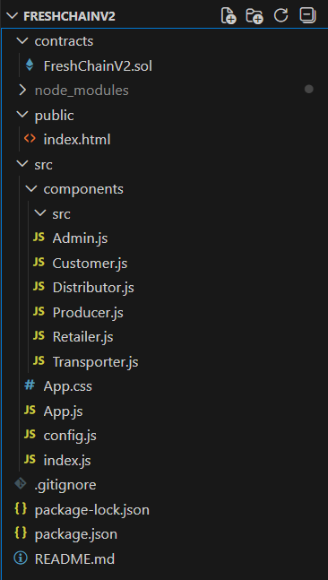

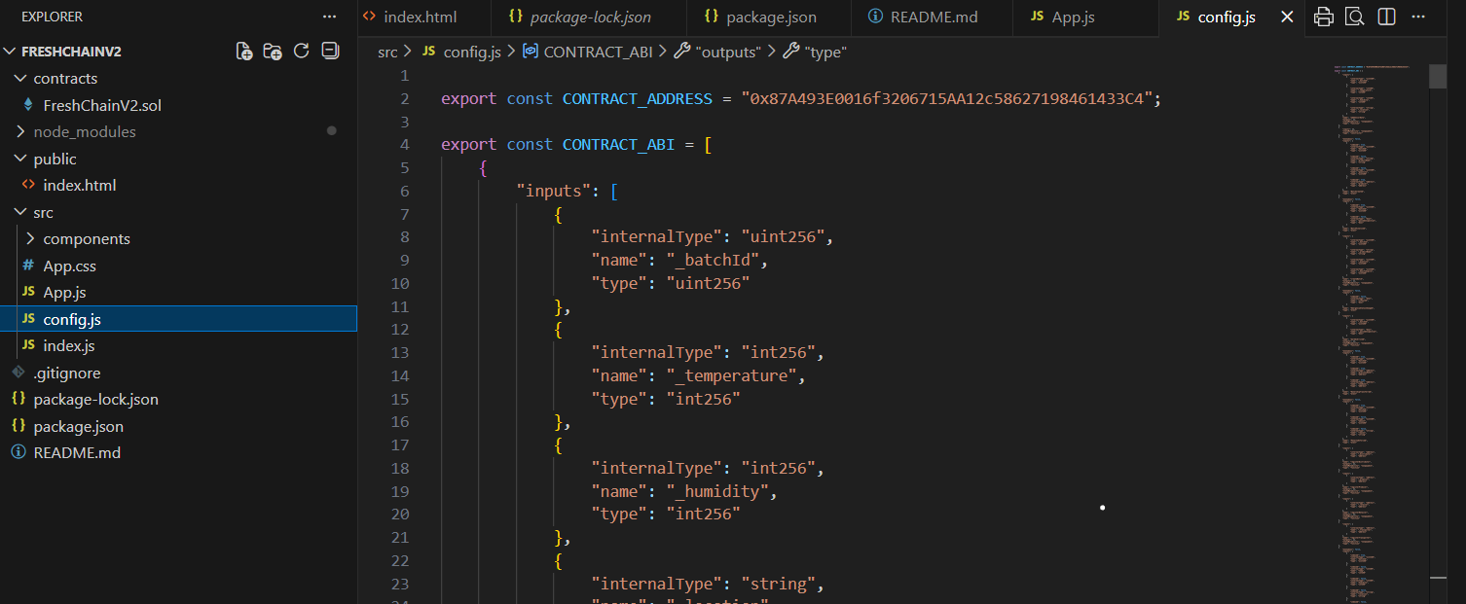

2. Technical Sequence of Operations
Data flows through the system using specific function calls. Here is how the key processes interact:
A. Batch Creation & Ownership Transfer
- Creation: The Producer calls createBatch(). The contract validates the producer's role, assigns a unique Batch ID, and stores initial metadata (Name, Quantity, Expiry).
- Transfer: When the product moves to a Transporter, the transferOwnership() function is called. This updates the currentOwner address in the batch struct, ensuring only the current holder can update sensor data.
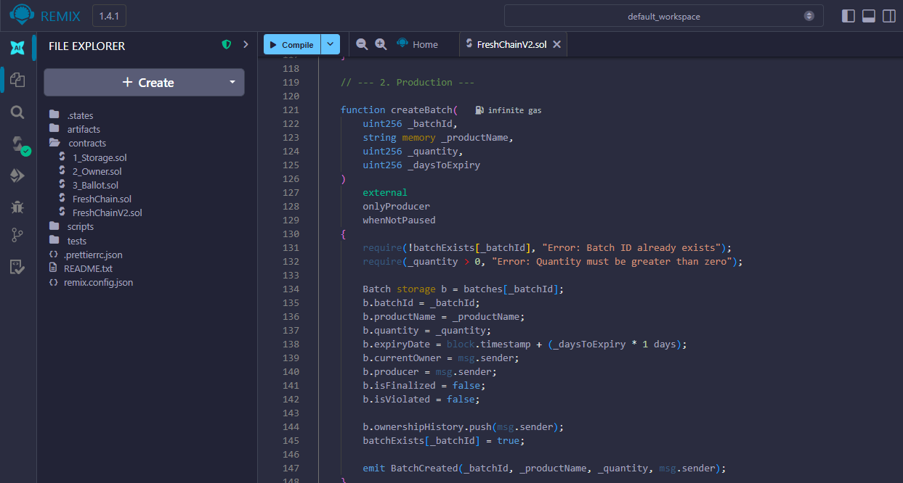

B. Sensor Data Recording & Violation Logic
- Input: The Transporter calls recordSensorData(id, temp, hum, loc).
- Validation: The contract immediately runs a conditional check:
if (temperature > maxAllowed) ->isViolated = true
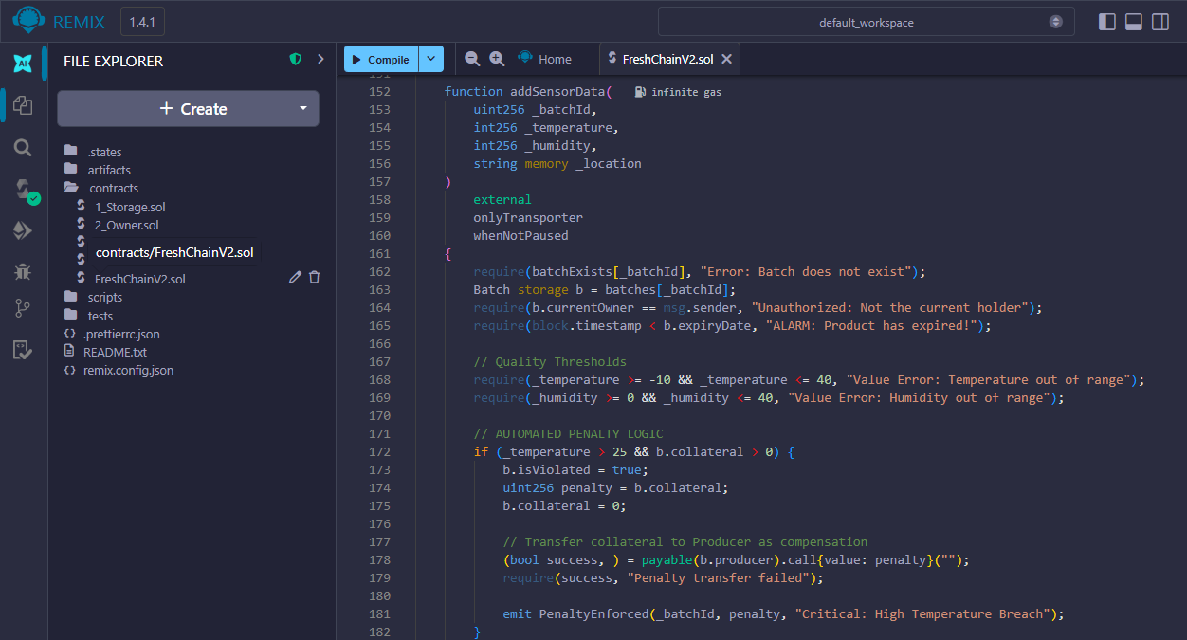

- Penalty: If a violation occurs, the contract executes an internal transfer, sending the Transporter's collateral to the Producer.
C. History Retrieval
- Fetch: The UI calls getBatchHistory(id).
- Response: The contract returns a Tuple containing the batch struct and an array of SensorLog structs. The frontend then parses this data to display the audit trail.
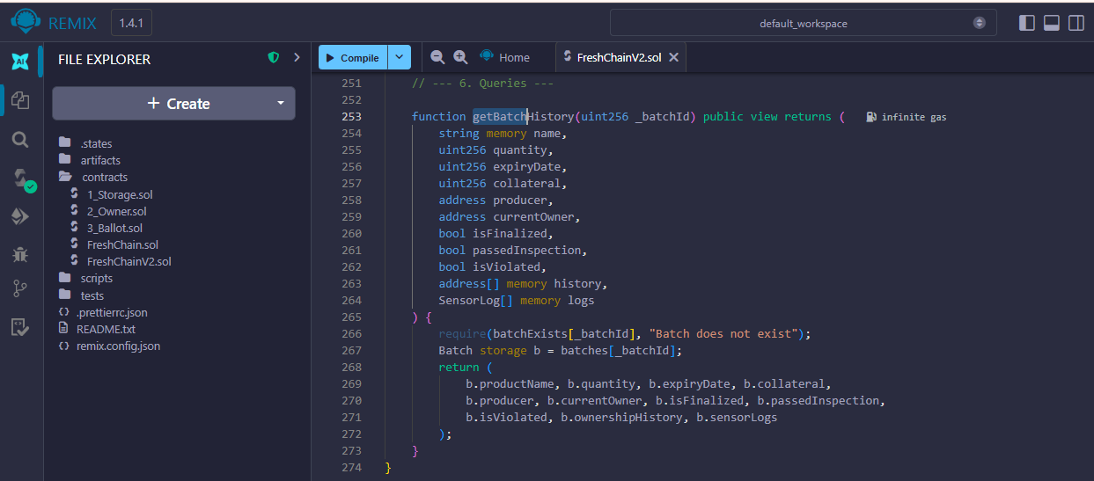

3. Application Activity Flow
The application follows a Request-Response-Sync cycle between the UI and the Blockchain:
- User Trigger: A user clicks a button (e.g., "Authorize Role" or "Track Product").
- Contract Call:
  - Read Actions: The UI calls a view function. Data is returned instantly without gas fees.
  - Write Actions: Ethers.js requests a signature from MetaMask. The user confirms the gas fee.
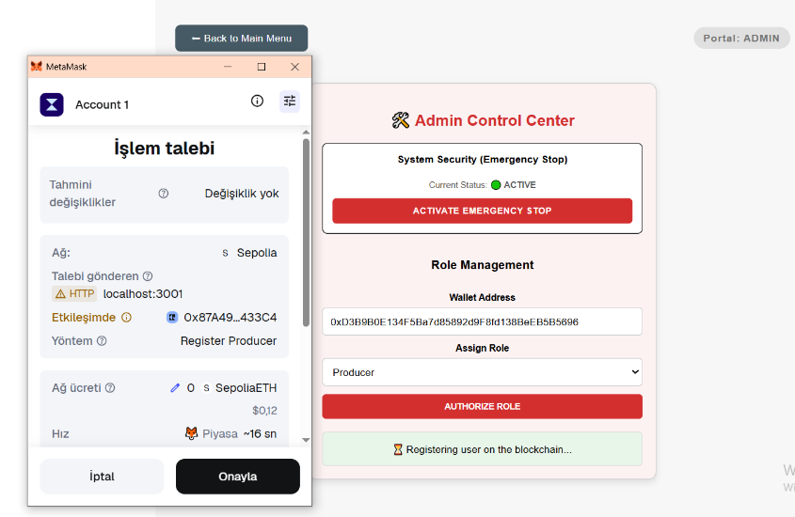

- Blockchain Processing: The transaction is bundled into a block. The contract state (e.g., isPaused or isViolated) is updated.
- UI Update: Upon transaction confirmation (tx.wait()), the frontend triggers a re-render or status update to show the result (e.g., "Role Authorized").

4.GitHub Repository Structure
The FreshChainV2 repository is organized to maintain a clear separation between the blockchain logic, the user interface, and the project documentation. This structure ensures that developers, evaluators, and stakeholders can navigate the project efficiently.
1. Directory Tree
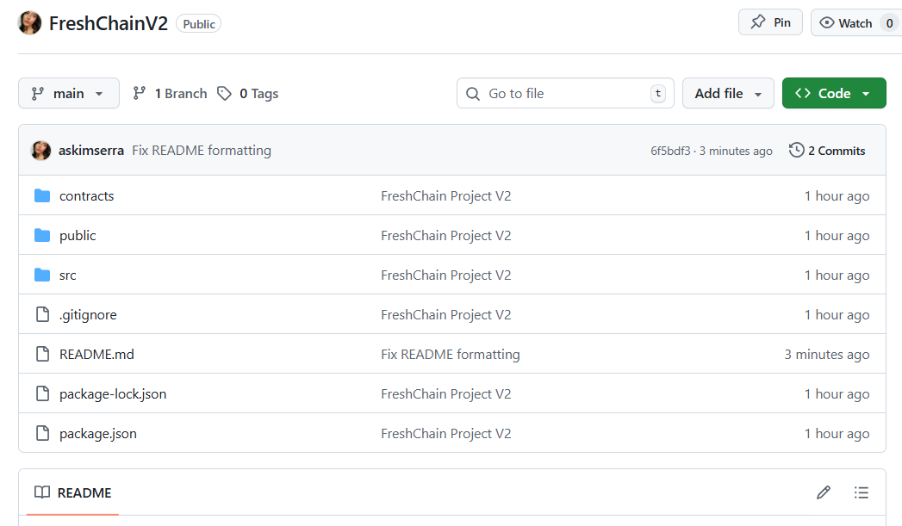
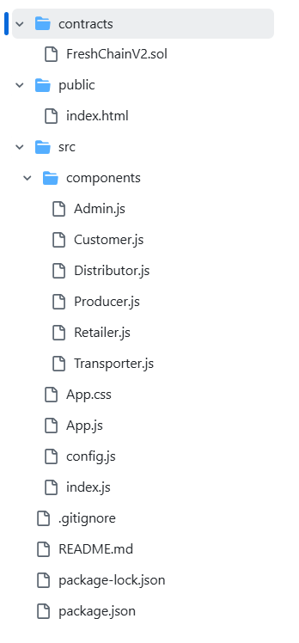

2. Purpose of Key Components
Smart Contract Folder (/contracts)
This folder contains the FreshChainV2.sol file, which is the "Single Source of Truth" for the entire system. It defines the rules for product creation, ownership transfers, and the automated penalty logic. It is the back-end engine that runs on the blockchain.
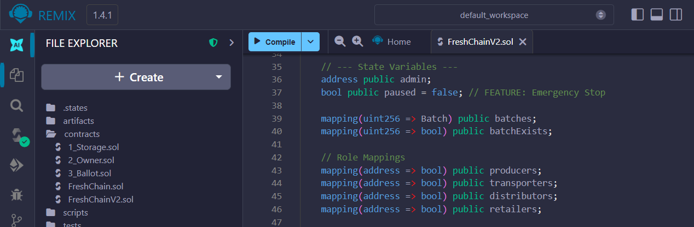

Frontend Application (/src)
The frontend is built with React. It serves as the bridge between the end-user and the smart contract. It handles user inputs (like temperature data), requests signatures via MetaMask, and displays real-time updates from the blockchain state.

Public History Page (Customer.js)
Within the frontend, the Customer.js component is specifically designed as the Public History Page. Its purpose is to allow anyone with a Batch ID to query the blockchain’s immutable history. It retrieves the audit trail (sensor logs) and displays whether the product’s quality was maintained throughout the journey.
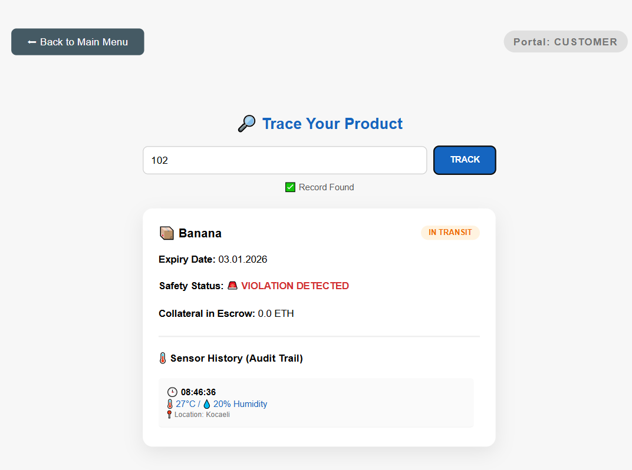

Configuration (config.js)
This is a critical file that contains the Contract ABI and the Deployed Address. Without this file, the frontend would not know how to communicate with the specific smart contract deployed on the network.

3. Integration of the Word Document
The Word document is integrated into the repository within the /docs folder for the following reasons:
- Centralized Documentation: By keeping the technical manual and project report inside the repository, the project becomes a self-contained package. An evaluator can clone the repository and have access to both the code and the full project context immediately.
- Version Control: Like the code, the documentation is subject to Git version control. This allows for tracking changes in project requirements and technical specifications alongside the actual code development.
- Evaluator Access: The README.md file in the root directory contains a direct reference to the /docs folder, guiding evaluators to the comprehensive Word document for a deep dive into the system’s theoretical and technical background.
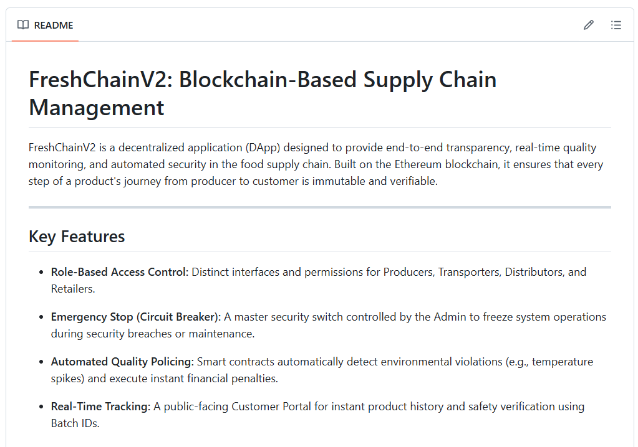
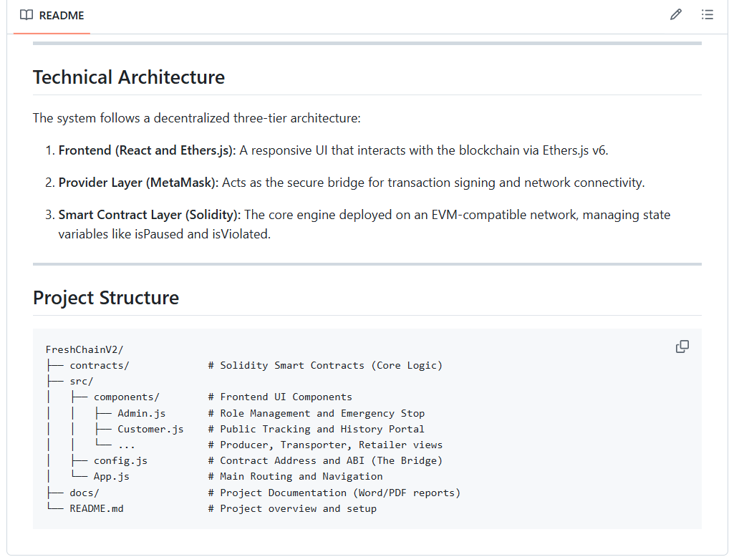

4. Application Activity Flow Summary
- Input: User actions in Admin.js or Producer.js trigger a transaction.
- Execution: MetaMask signs the transaction, and the Smart Contract in /contracts updates the state.
- Verification: The Customer.js (History Page) fetches the updated state and logs to show the user a transparent, immutable record of the product's journey.

